Business Architecture Meta-Model

Purpose and objectives
This document describes an attempt to construct a minimal meta-model (in UML) for the primary artifacts used in the practice of business architecture. The objectives of this attempt are:
- To capture the structural and delivered value aspects of businesses of a particular type;
- To allow models created with this meta-model to integrate with other models that may be or have been created for a particular enterprise
The structural and delivered value aspects of the meta-model include Value Maps, Capability Maps and Information and Product Maps.
Other models that may be integrated with a business architecture model defined by this meta-model include:
- Strategy models such as Kaplan-Norton Strategy Maps, Hoshin-Kanri, OMG’s Business Motivation Meta-Model.
- Organization models such as hierarchical organization charts and matrix charts
- Requirements models (for IT projects or deliverables built by contract)
- Business Models such as the Business Model Canvas
The integration approach taken in this exercise uses “proxy” elements that are associated with corresponding elements in the integrated models. These proxy elements do not attempt to duplicate the entire external model; rather, they duplicate a small number of concepts and relationships that are generic to variants of an external model and are associated with elements of the business architecture model. There are very many methods used for strategic planning, for example, and they all share a generic core.

The meta-model

Value Map
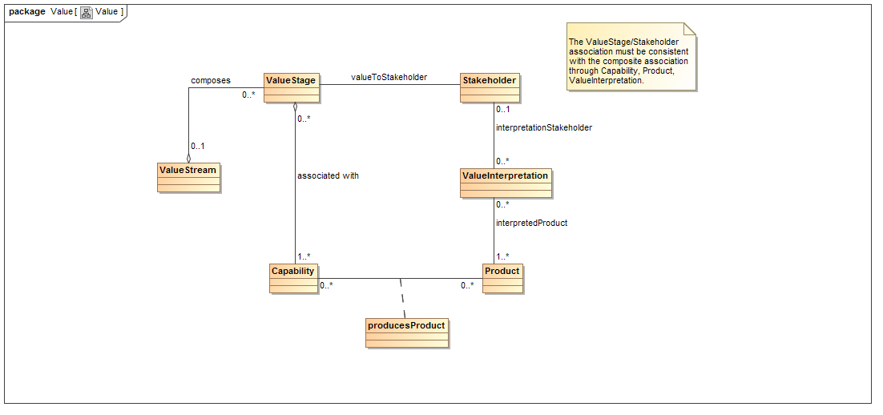

Explanation
A ValueStream is composed of ValueStages. A ValueStage has one or more Stakeholders who receive value from something that results from the ValueStage. The something that results from a ValueStage and produces value to a Stakeholder is implicit in the valueToStakeholder association.
To make the something explicit, one or more Capabilities need to be associated with the ValueStage. A Capability is an abstract thing that represents an ability that an enterprise must have to perform work and to produce Products. A Product is also an abstract thing that represents whatever is produced by the Capability. A Product has some value to a Stakeholder, but that value may not be the same for all Stakeholders. The different values are represented here by an abstract element called a ValueInterpretation that is associated with a Product and a Stakeholder. This can also be represented in UML as an association class.
When the lower part of this meta-model is instantiated in a model, it must be the case that the associations and classes linking ValueStage to Capability to Product to ValueInterpretation to Stakeholder are equivalent to details of the valueToStakeholder association. In the evolution of a business architecture model, the valueToStakeholder association may be produced first and later elaborated into the aforementioned association chain. If that association chain should be broken, the valueToStakeholder association may remain, but loses its elaboration. A valueToStakeholder association may have multiple such elaborations.
The typical Value Stream presentation is a view on the underlying business architecture model. This view may select specific model elements for viewing and it may replace association/class chains with representations that look like associations. The view may introduce an ordering on the ValueStages in a ValueStream.

Open Issues
There is no element that represents value in this meta-model, and it is an open question whether the business architecture meta-model needs an explicit element that represents value.
In some practiced Value Maps, the ValueStages have pre-conditions and post-conditions. The initial ValueStage may have a distinguished set of preconditions that are said to be the trigger conditions. More work needs to be done to establish the types for these conditions and to define constraints between them and the Product and Information meta-model elements shown in the Capability Map section. Such pre-conditions and post-conditions may also be found in external process and state models of the line of business, so if these meta-model elements are added, they should also be capable of functioning as proxies.

Capability Map
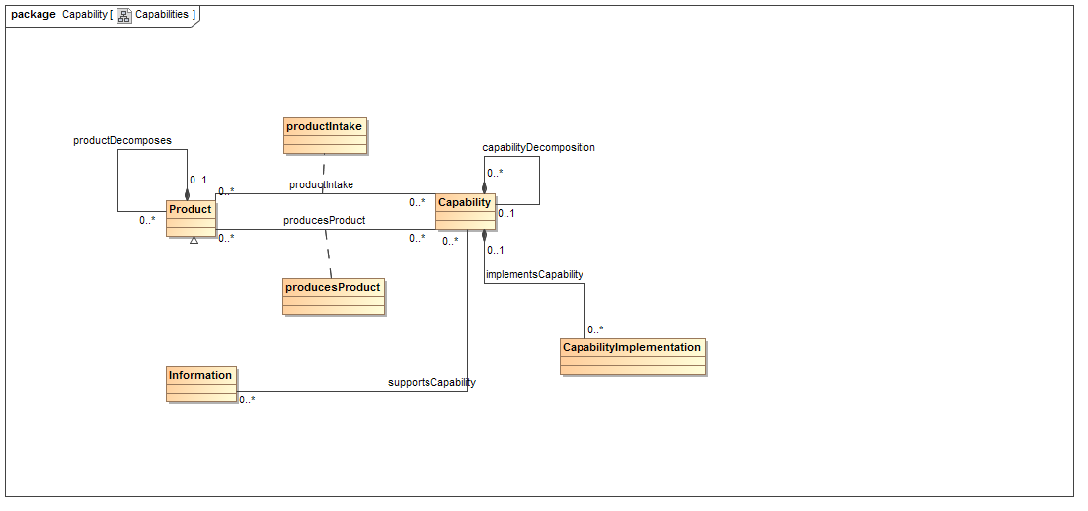

Explanation
A Capability Map may cover an entire enterprise, a line of business or a part of a line of business. A Capability Map presentation is a view on the underlying model that may exclude some model elements and substitute associations for association/class chains.
A Capability produces one or more Products as noted in the section on Value Map. A Capability also takes in Products as shown in the above meta-model diagram. The productIntake association is modeled as an association class as the association may be characterized by various attributes and participate in other relationships in the meta-model. The existence of this association implies nothing about the lifecycle of a real product that is modeled by a Product in this meta-model; one should not conclude that the real product is consumed by the capability or left untouched or modified in some way.
Information is a specialization of Product as Capabilities may (abstractly) produce new Information from Information that is made available to them. In addition, Information supports decision making that is part of what the Capability does. This special role for Information is captured in the supportsCapability association.
A Capability may be associated with one or more CapabilityImplementations which represent real world organization units and their supporting automation. CapabilityImplementations can be linked to elements in other models such as organization charts and budgets so that an analysis can produce summary information such as the total budget allocated to each Capability for a particular business unit. In addition, CapabilityImplementations are crucial to strategy integrations.
Capabilities are decomposable to an arbitrary depth. Capabilities are not shared by different parent Capabilities. This restriction insures that each Capability appears just once in the resulting Capability hierarchy. This restriction is critical to preserving the independence of the Capability Map from the structure of any particular enterprise. When new practitioners realize that this restriction is a part of the meta-model, they typically wonder about the meaning and purpose of the capability hierarchy. The meta-model does not define this purpose but the meta-model does allow the Capability Map to record multiple hierarchy types because capabilityDecomposition is a class association and can have attributes and participate in other associations. Some practitioners create hierarchies based on categorizations of the Capability model elements such as whether the Capability performs executive work, support work or operational work. Others will use the capability hierarchy to group together Capabilities that intake or produce a common product such as Information about a customer or supplier.
Products are also decomposable, but much less is asserted about the decomposition of a Product.

Open Issues
The supportsCapability association may need to become a class association to allow the association to have attributes and participate in other associations.
The implementsCapability association may need to become a class association to allow for the association to have attributes and participate in other associations.
What are the rules for decomposition of a Product?
Should CapabilityImplementations be restricted to Capabilities that have no children? If not, what modeling value would a CapabilityImplementation have that is associated with a Capability that has been decomposed? See the section on Strategy and the section on Business Unit.

Strategy Map
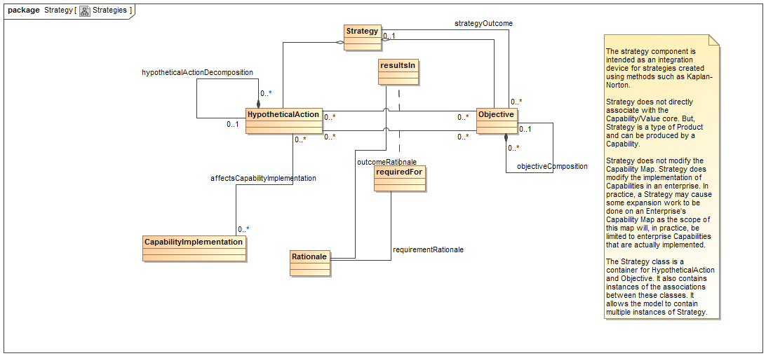

Explanation
There are very many ways to represent strategy and each way may have one or more characteristic diagrammatic representations. The meta-model shown here consists mostly of proxies that are intended to be linked to whatever strategy model the practitioner may encounter. In particular, most strategy models contain an element that corresponds to HypotheticalAction and represents an action that the strategy recommends, as well as an element that corresponds to Objective, and represents the hoped-for outcome of the action. HypotheticalActions may resultIn Objectives being attained. Additionally, certain Objectives may be requiredFor a HypotheticalAction to take place. In the meta-model, these are class associations to allow them to have attributes and participate in other associations.
In particular, the associations between HypotheticalAction and Objective may be associated with Rationale elements. The Rationale element represents an argument for or against the HypotheticalAction resultingIn an Objective or an Objective being requiredFor a HypotheticalAction to occur. Rationale elements are optional and may be used directly in the business architecture model when the external strategy model does not support recording of rationale.
A HypotheticalAction is expected to have an impact on several parts of the enterprise or line of business. This impact is represented by the affectsCapabilityImplementation association. Much of the time, the HypotheticalAction of the strategy will impact the staffing, resources or processes that are associated with the CapabilityImplementation. It is possible to represent a HypotheticalAction that results in the creation of a real capability in a line of business by assuming the existence of a CapabilityImplementation with no staff or resources and then adding staff and resources in the HypotheticalAction.

Open Issues
It has been assumed that a Capability exists in a capability map whether or not it is realized in a particular line of business for which that capability map is suitable. This makes the capability map independent of the realization of that Capability in any particular line of business. However, it would not make sense to have a Capability that is not realized in any existing or proposed future line of business. If, as an alternative, there was an association between HypotheticalAction and Capability and the meaning of this association was to create a Capability, this would cross a boundary between the model world in which Capabilities are timeless and a different model world in which CapabilityImplementations can come and go as the line of business being modeled changes. In UML, realizations are special associations that are used to cross such model world boundaries when one wishes to produce a model of a software system showing what the executions state looks like as the software system is executed.

Business Unit
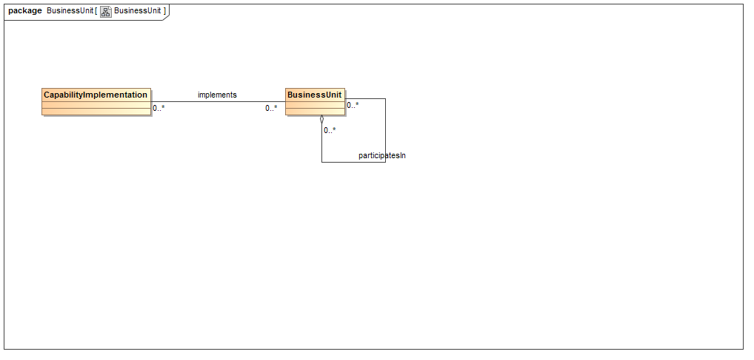

Explanation
The BusinessUnit represents a component of an organization that is a line of business, together with its resources, staff and IT support. It can represent an element of an org chart (typically hierarchical) or an element of a matrix organization as the participatesIn association is an aggregation rather than a composition.
The BusinessUnit may be associated with one or more CapabilityImplementations. The relationship between the BusinessUnits and the Capabilities is rarely aligned 1-1. A CapabilityImplementation is aligned 1-1 with its Capability parent, but a many to many association may exist between the CapabilityImplementation and the BusinessUnit. In any particular instance of this association, the CapabilityImplementation represents the fraction of the resources, staff and IT support required by the BusinessUnit to support the Capability that is parent of the CapabilityImplementation.

Open Issues

Requirements
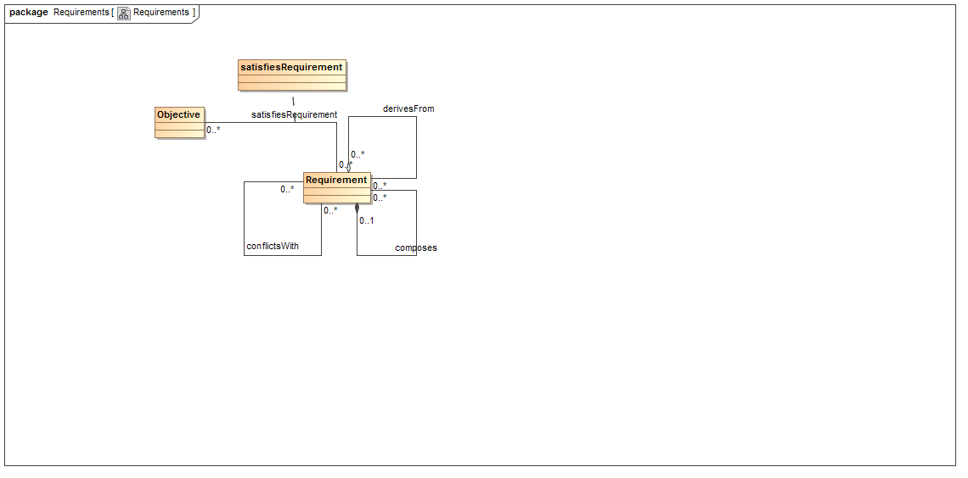

Explanation
There are several published requirements meta-models They all define a requirement element and various associations between requirements elements to model derived requirements, requirements composed from other requirements and requirements that conflict with each other. The Requirement class in this diagram is a proxy for those requirement elements. In addition, the business architecture meta-model duplicates the primary associations between requirements noted above.
The Requirement element is associated with an Objective element by the satisfiesRequirement association. This association is generally many to many as Objectives and Requirements will typically not align. The association allows checking that the requirements in a requirement model align with the Objectives of the strategy model that the requirement deliverable is supposed to support.

Open Issues
The business architecture meta-model Objective may benefit from associations indicating derivation and conflict as these associations are useful in determining the feasibility of a strategy.

